|  |
| --- |
| ITE3006: IT Essentials - Web |
| EA2 – A Client – Side Web Site of Your Own Interest |
| Promotion of Health Care – Health Smart @HK |

|  |
| --- |
| Alex Li & Kenson Chan  2022/11/15 |

1. Introduction

This website – Health Smart @HK, which is modern design webpages. Due to user use different kind of device to login the webpages, including the desktop device or mobile device. So, our webpages framework which is designed to be automatically change the size of the content to fit into different size of screen. The goal of this webpage, which increases the usability, readability & reliability.

All these webpages and design based on HTML, CSS, JavaScript code to create. In below pages will be further describe the webpage design.

1. Webpage Frontpage Design
   1. Design History

Before webpage create, we have used paint.net to draft out below basic webpage design.

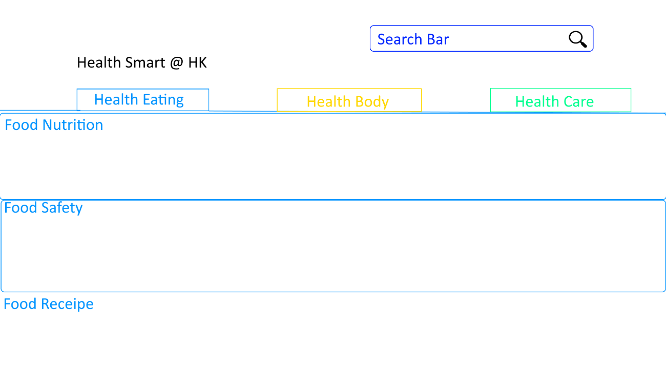

Below is basic webpage framework by HTML, separate header, tab & Section, and using tab page design to separate different content of webpage, which allow user easy access.

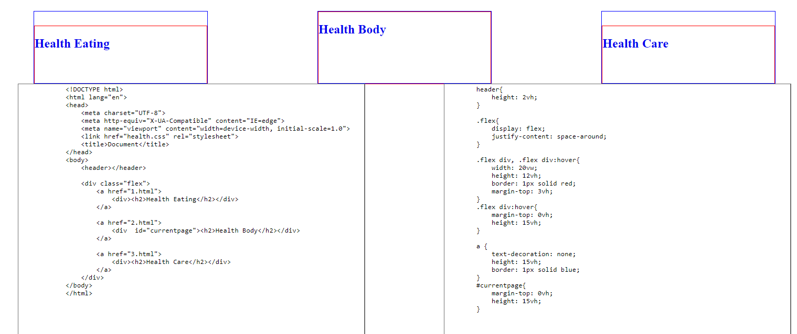

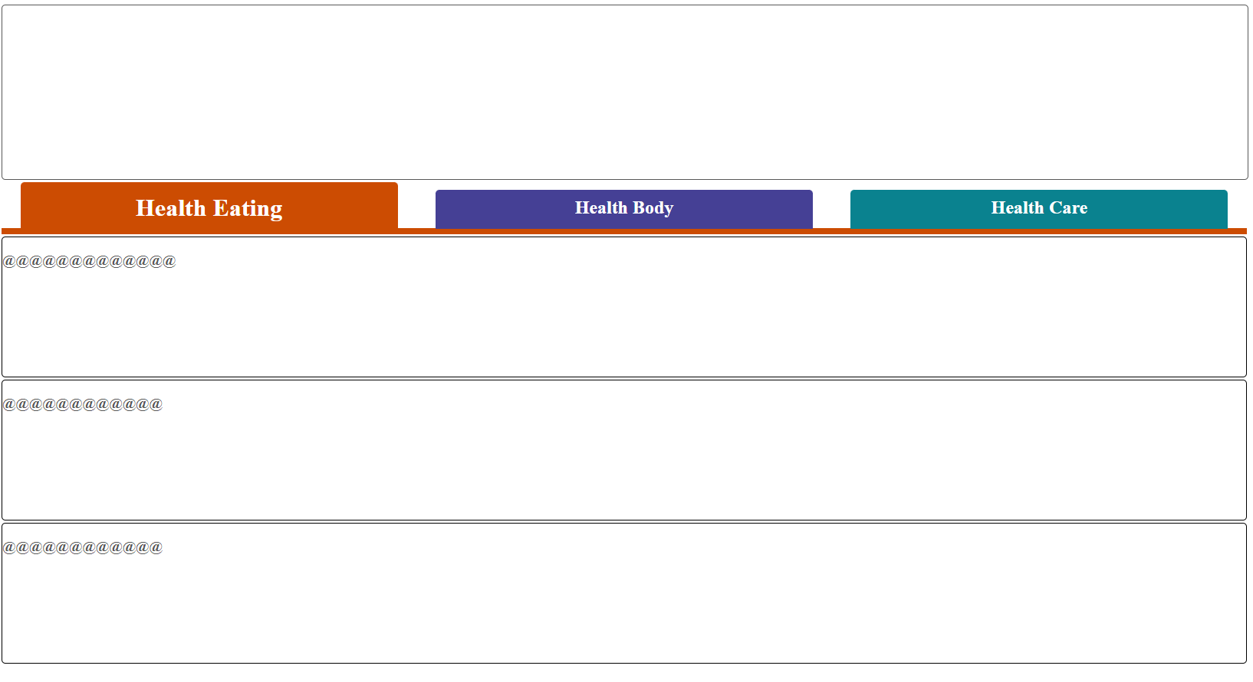

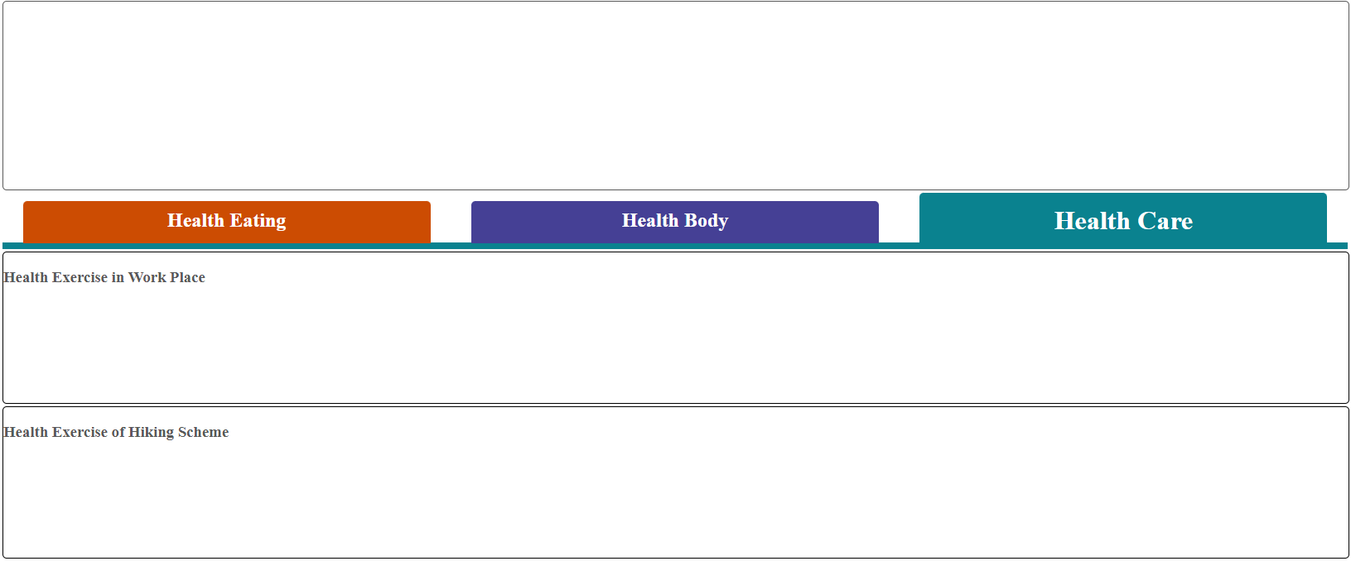

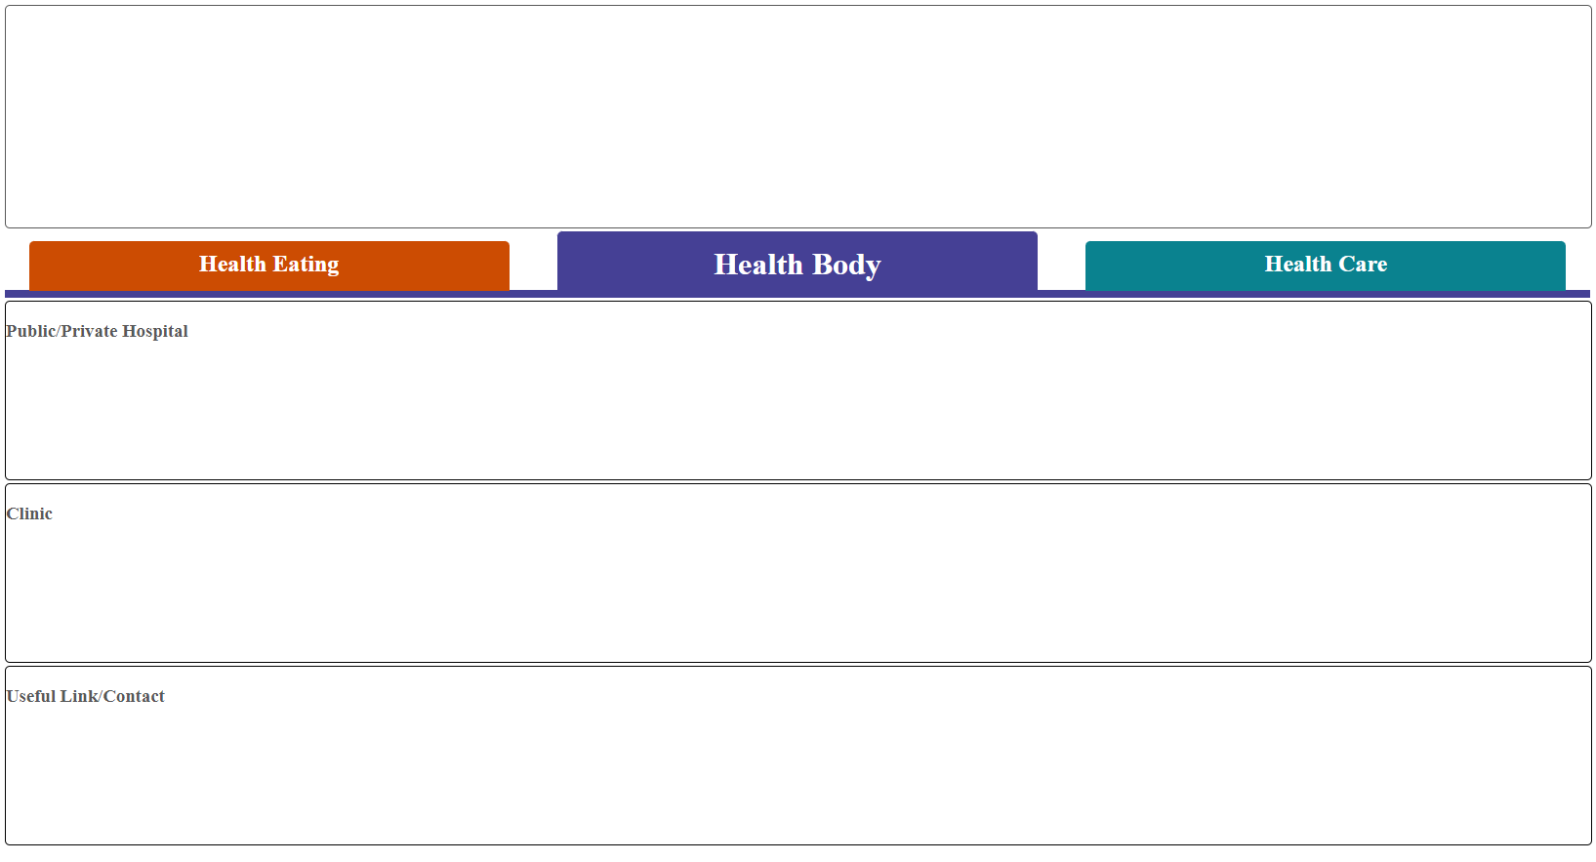

Then the webpage framework of section area, which separate into three small parts

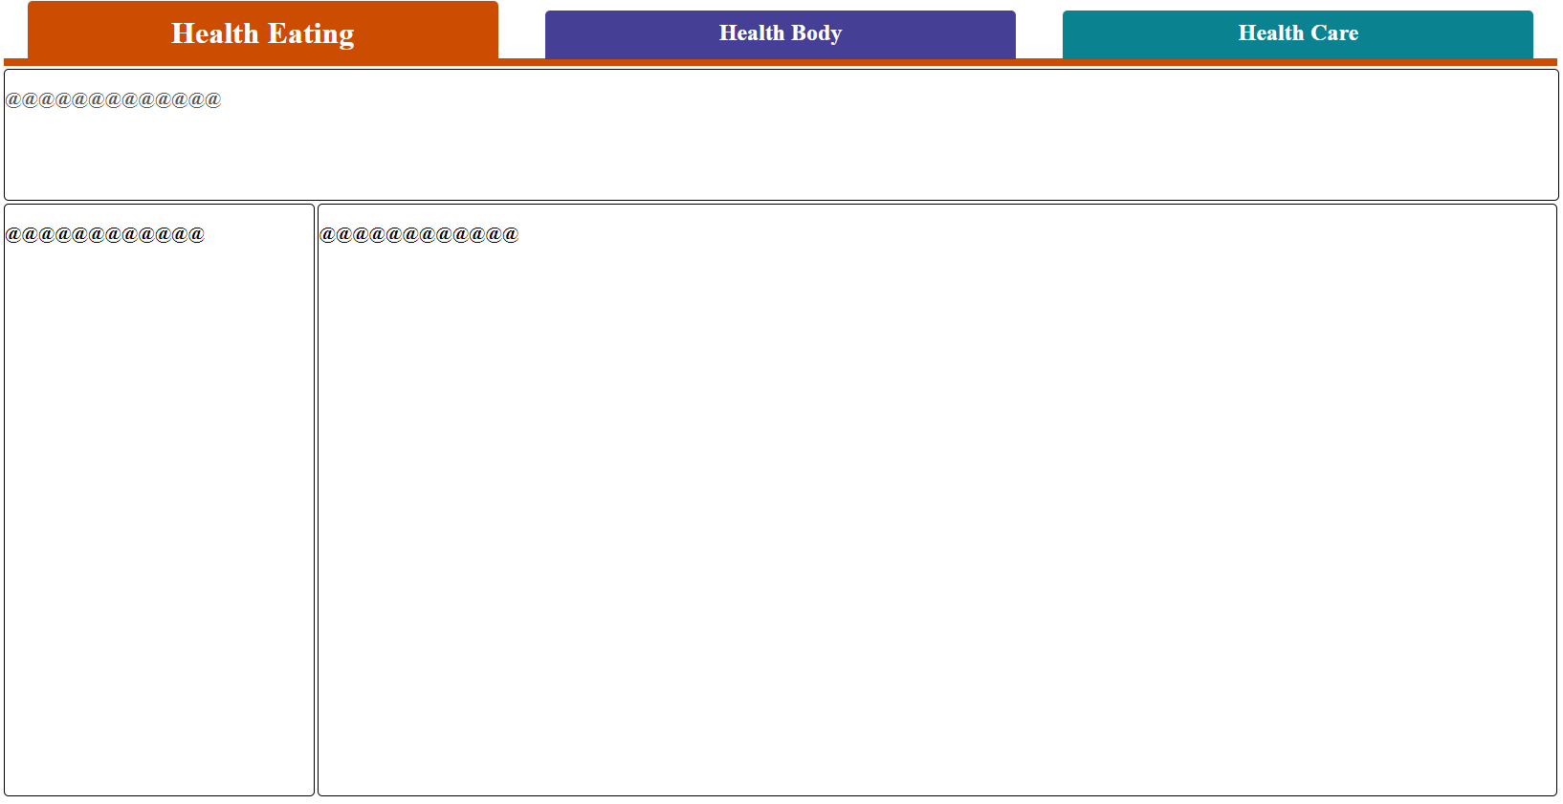

Before we find artwork material, we use different kinds of colour to show the basic framework of the webpage

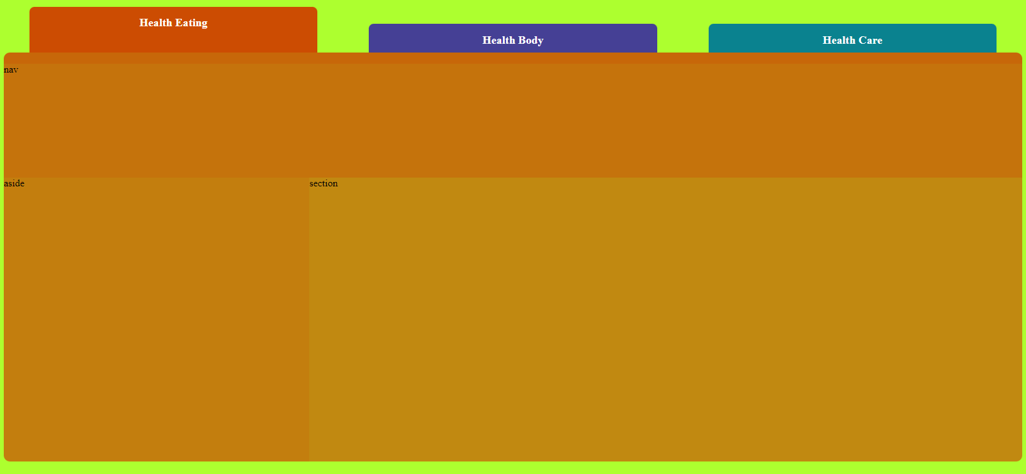

Then we start to decide what kind of information put in those area, and the left-hand side of the section will be act as the navigation bar, the right-hand side of the section will be act as the content area to show the main information.

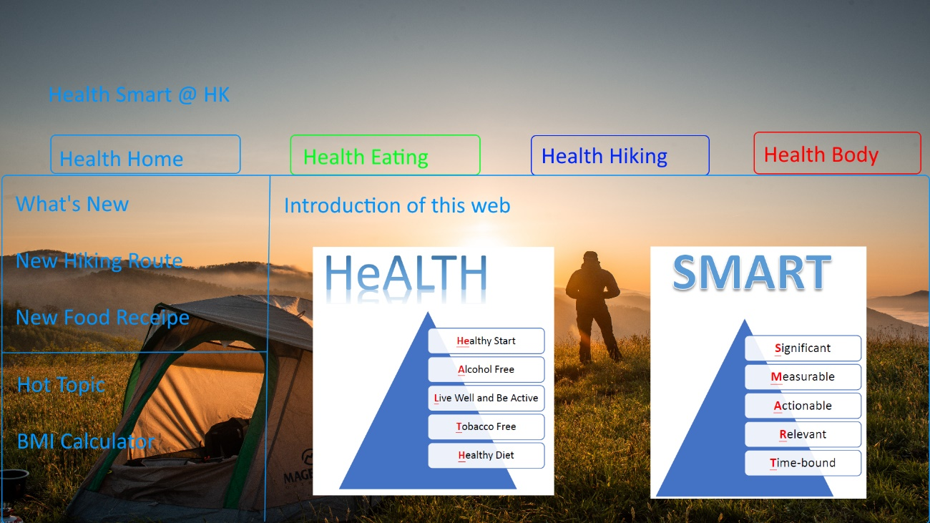

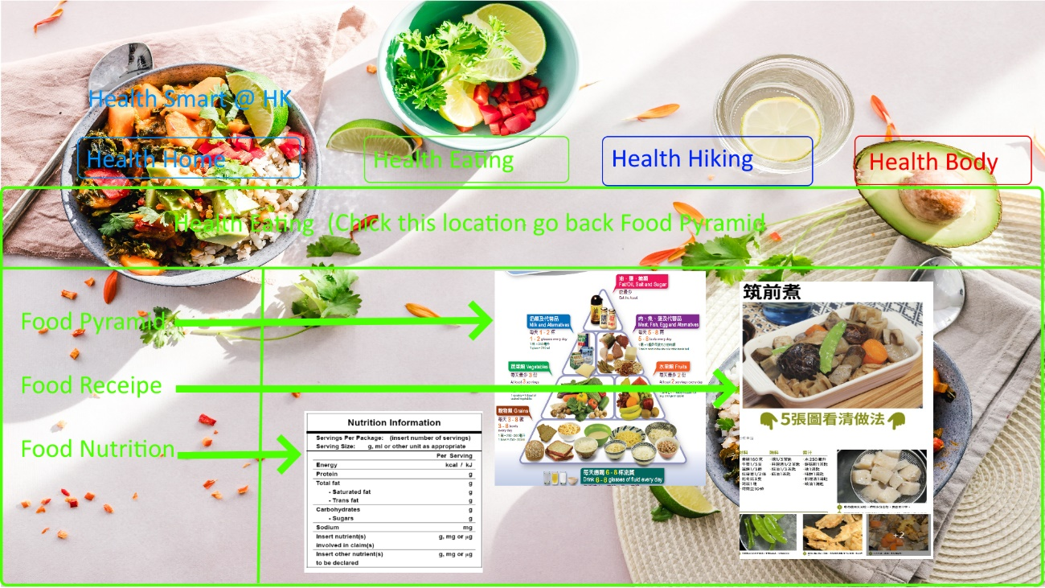

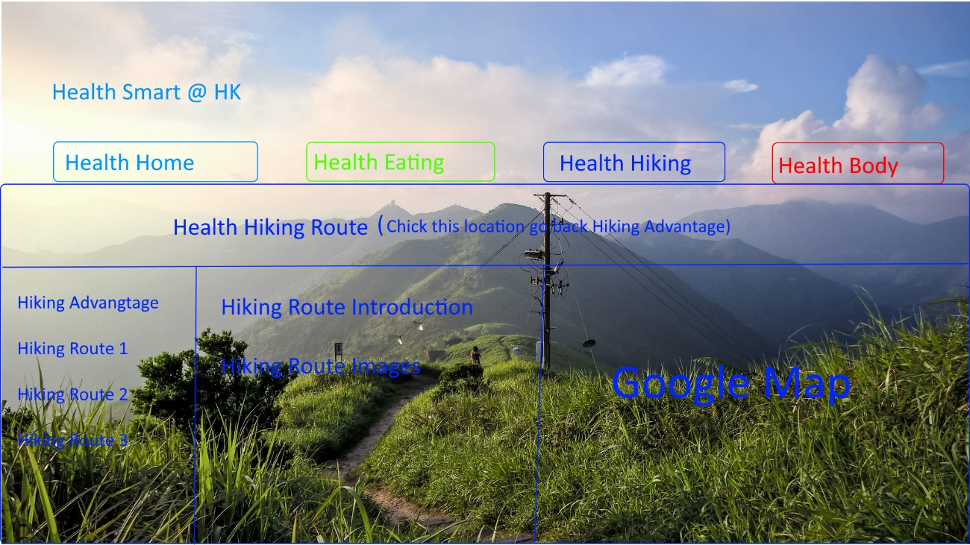

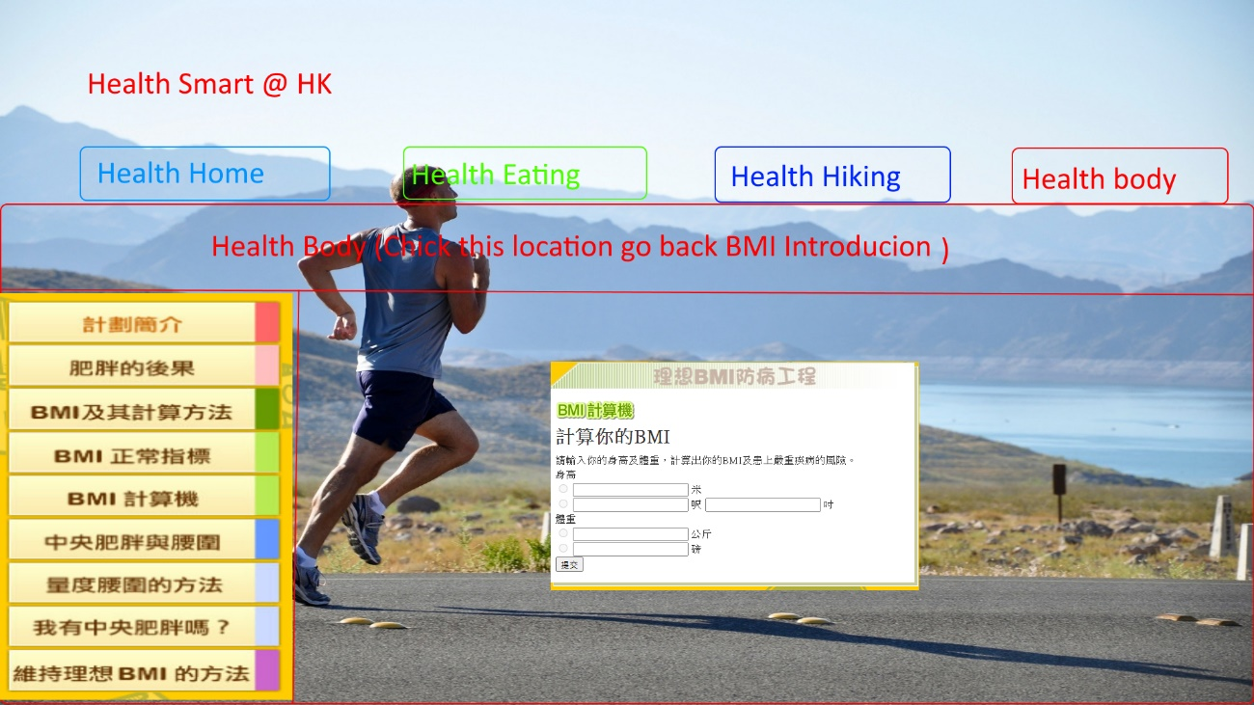

1. Webpage Function Design
   1. Responsive web design

Smaller Size Screen – Which fit for mobile device to read.

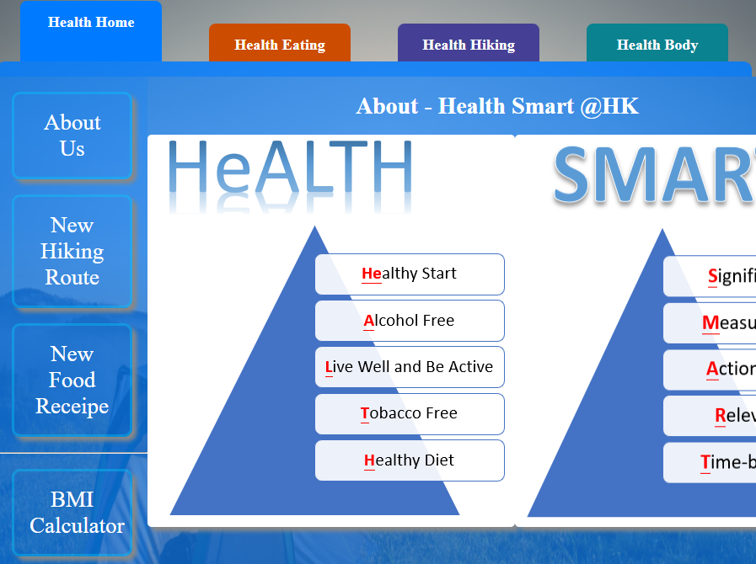

Bigger Size Screen – Which fit for desktop device to read

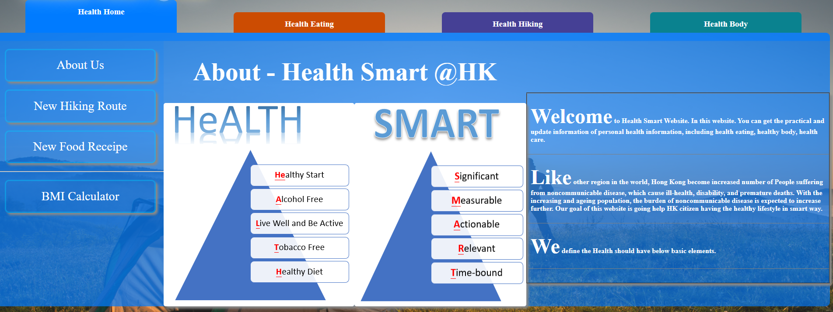

* 1. Animation of the Section

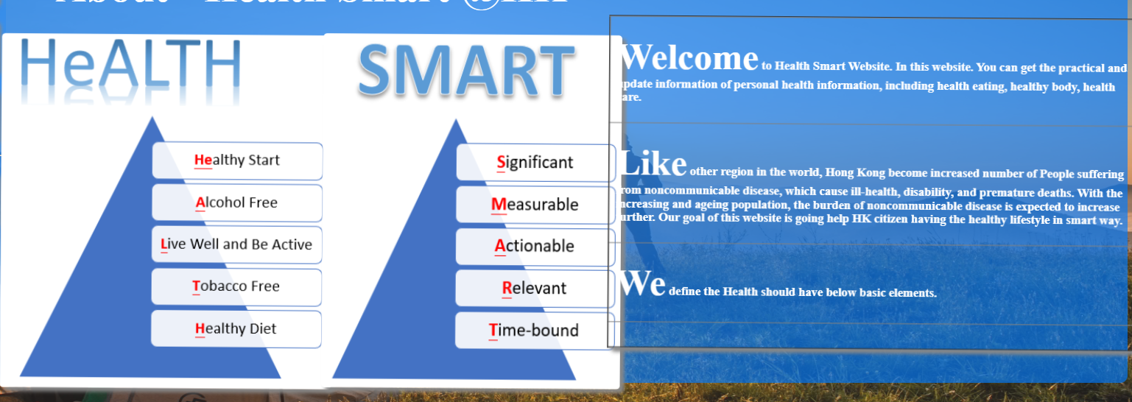

* 1. Hover of the button

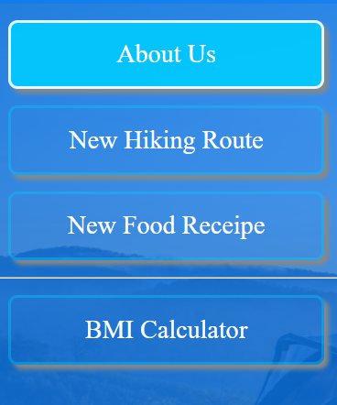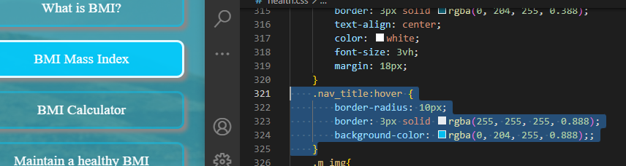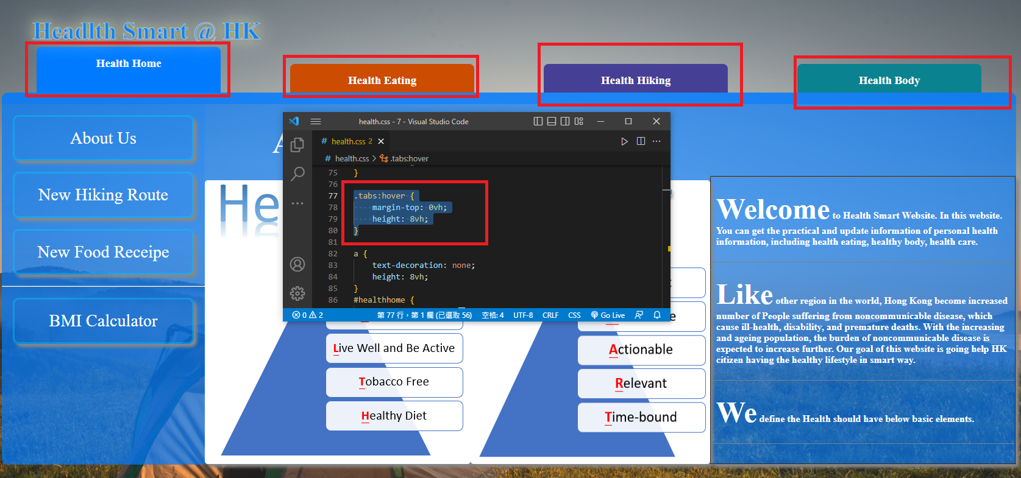

* 1. Hover of the form

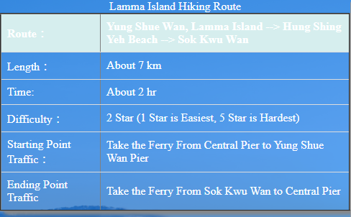

* 1. Form with CSS, JavaScript & Check Value
     1. CSS

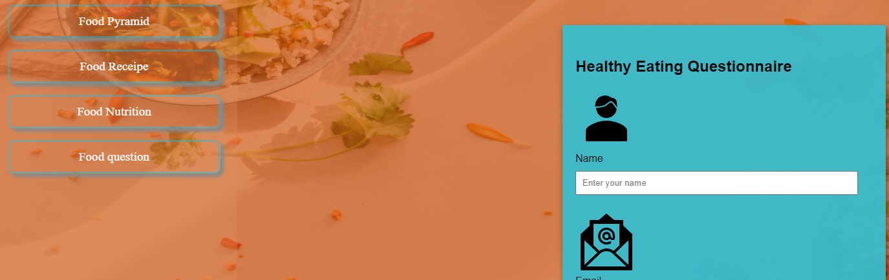

* + 1. Check Value

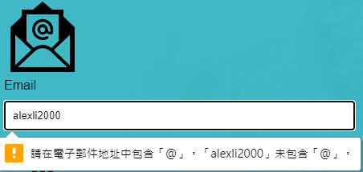

* + 1. JavaScript & Alert

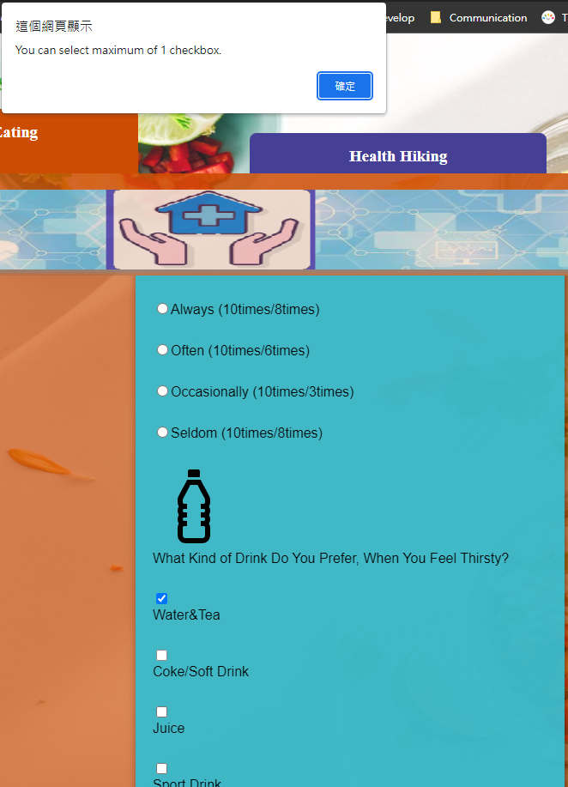 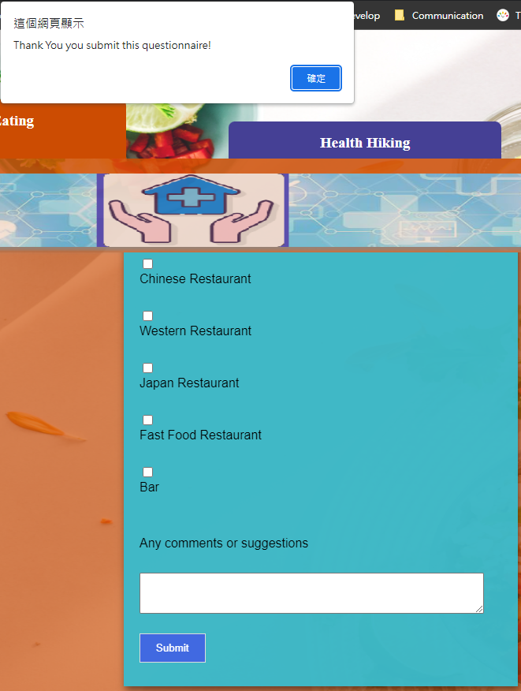

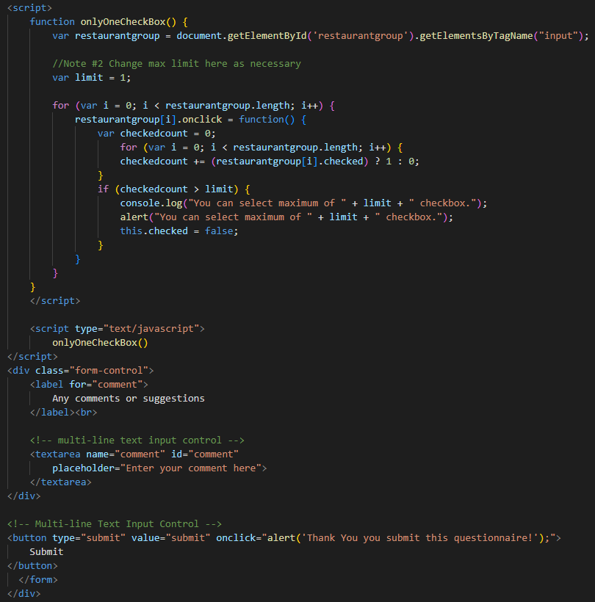

* + 1. iFrame – Google Map

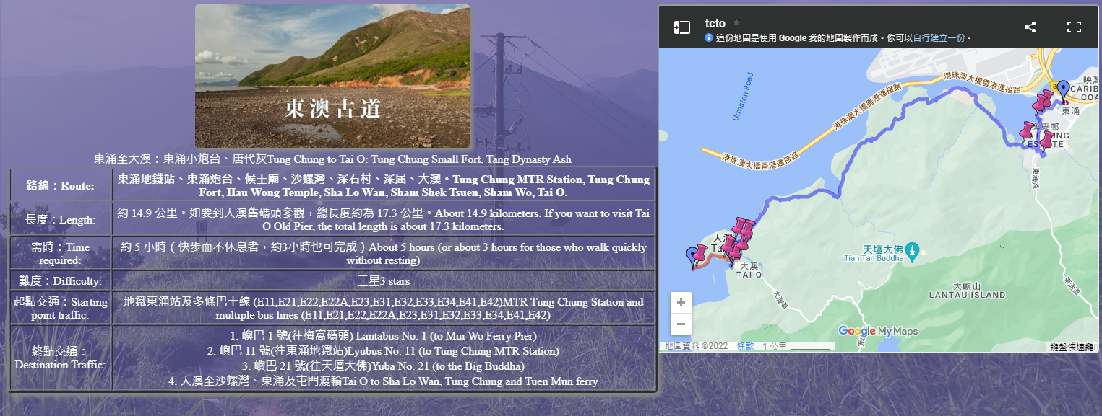

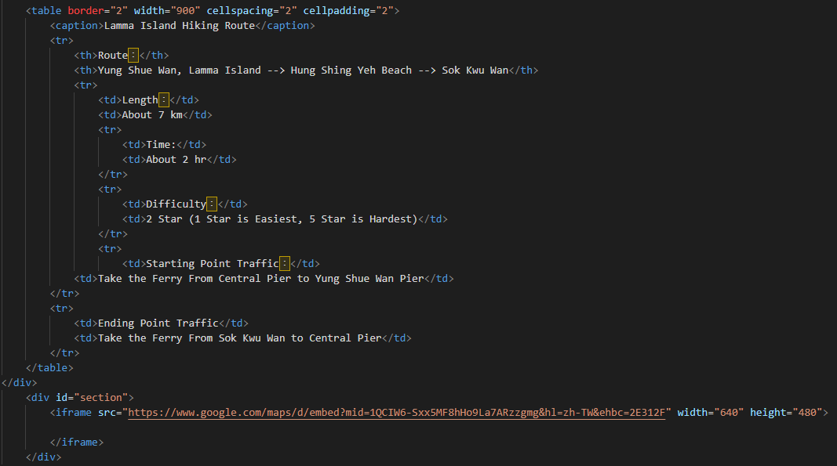

* + 1. BMI Calculator – JavaScript

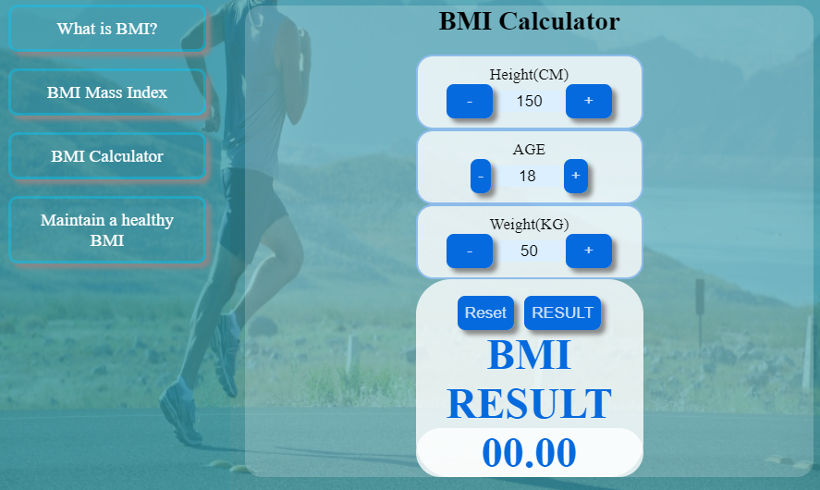

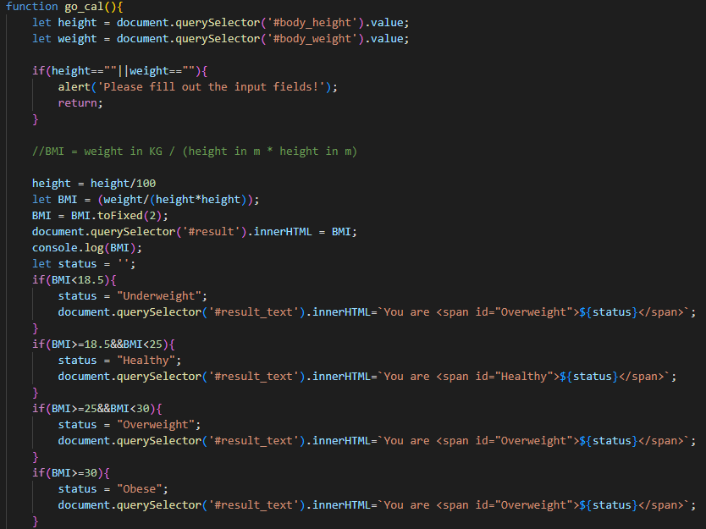

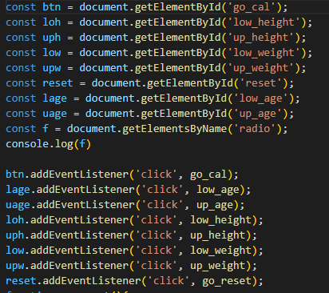

* + 1. Button Hover - CSS

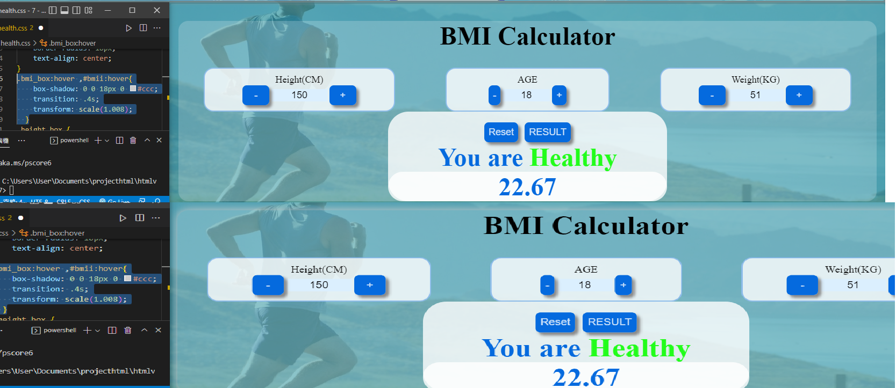

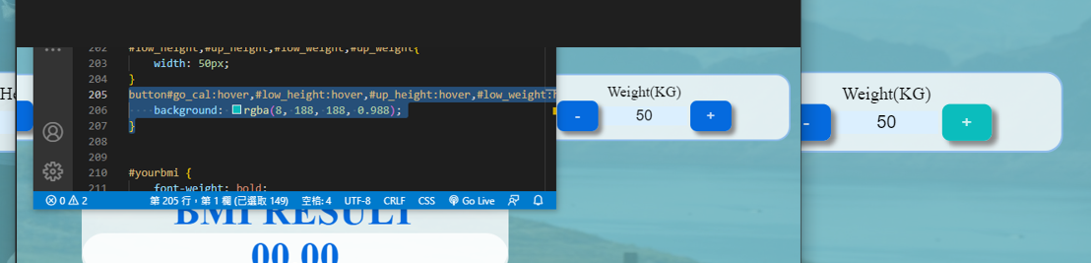

* + 1. Load on animation - CSS

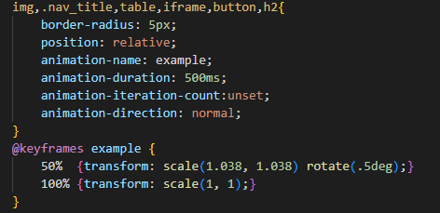



* + 1. Media for mobile - CSS

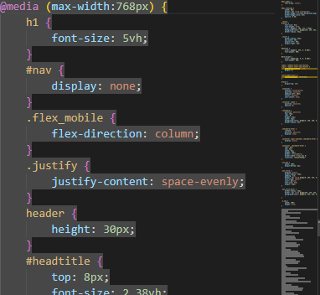

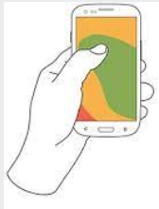

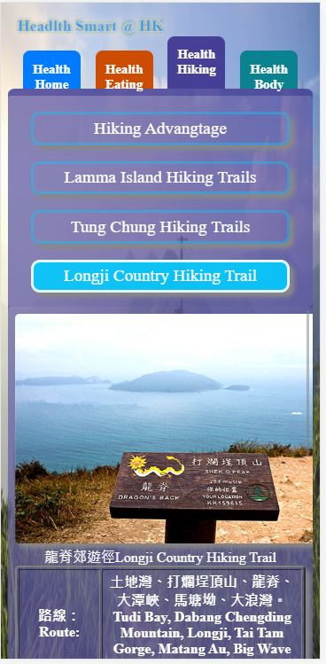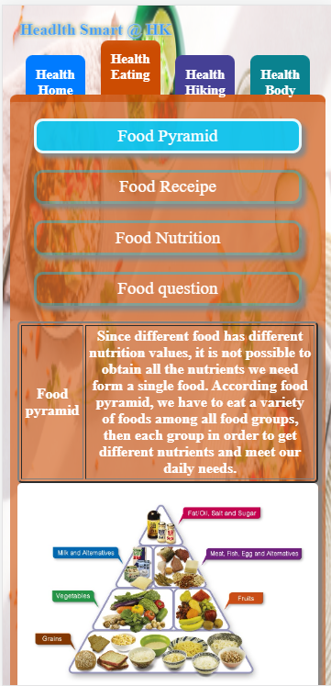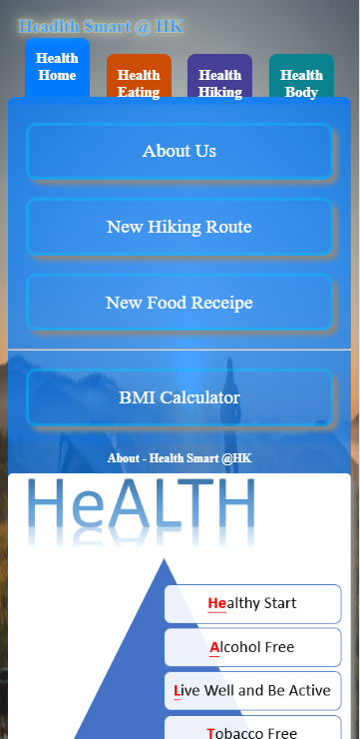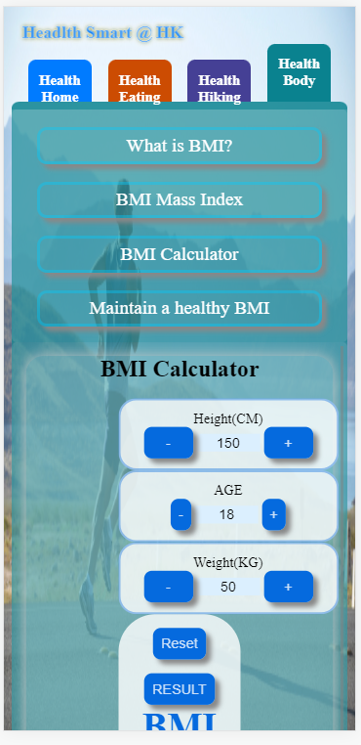

**That’s all we like to mention for today.**  
**以上就是我們想談論的事情。**

**That brings we to the end of my presentation today.**  
**我們的匯報就到此完結了。**

**Here comes the Q&A session,If you have any questions concerning the presentation, please don’t hesitate to ask.**  
**現在來到問答環節,如果你對這個匯報有任何疑問，不妨提出。**

**Thank you for listening.**  
**謝謝你的聆聽。**

**Thank you for your attention.**  
**謝謝你的聆聽 / 關注。**

**Thank you for attending this meeting and paying attention for our presentation.**  
**感謝你出席是次會議，及專注於我們的匯報。**